淄博十八中2020年高一新生线上缴费通知

根据山东省教育厅要求，2020年高一新生通过山东非税通缴平台统一缴费。方法如下：

1、微信、支付宝扫描二维码，跳转到山东非税统缴平台

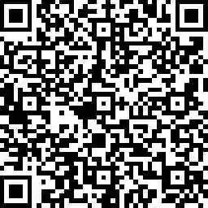

山东非税通缴平台

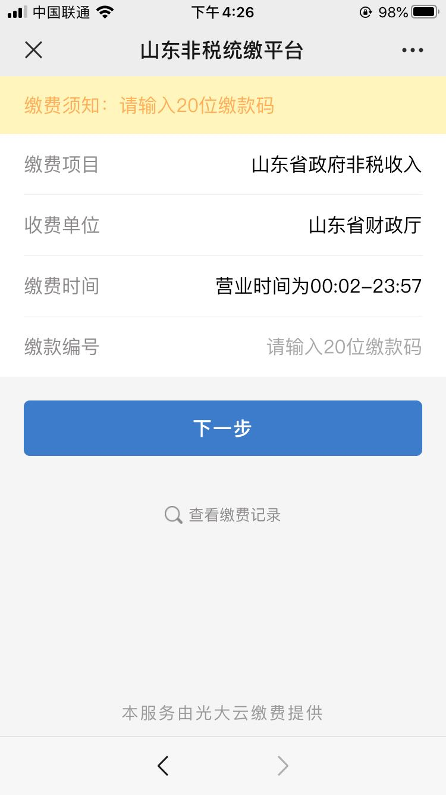

2、录入20位缴款码，点击下一步，完成缴费。

|  |  |
| --- | --- |
| **缴款码** | **姓名** |
| 37030020000001706300 | 于振杰 |
| 37030020000001706298 | 于韶玥 |
| 37030020000001705615 | 万港琨 |
| 37030020000001705172 | 马小婷 |
| 37030020000001705201 | 马用滨 |
| 37030020000001705210 | 马泽宇 |
| 37030020000001705180 | 马晓奕 |
| 37030020000001705199 | 马新政 |
| 37030020000001705914 | 王一心 |
| 37030020000001705965 | 王子强 |
| 37030020000001705754 | 王乐阳 |
| 37030020000001705762 | 王宁 |
| 37030020000001705877 | 王兴智 |
| 37030020000001705922 | 王宇飞 |
| 37030020000001705623 | 王安琪 |
| 37030020000001705789 | 王启明 |
| 37030020000001705957 | 王孜毅 |
| 37030020000001705640 | 王昊庆 |
| 37030020000001705658 | 王昊昕 |
| 37030020000001705682 | 王佳怡 |
| 37030020000001705842 | 王欣睿 |
| 37030020000001705703 | 王金宇 |
| 37030020000001705631 | 王宝明 |
| 37030020000001705720 | 王俊杰 |
| 37030020000001705893 | 王彦镔 |
| 37030020000001705690 | 王洁心 |
| 37030020000001705906 | 王洋 |
| 37030020000001705930 | 王语硕 |
| 37030020000001705826 | 王玺瑞 |
| 37030020000001705666 | 王浩权 |
| 37030020000001705674 | 王浩然 |
| 37030020000001705746 | 王浚铖 |
| 37030020000001705973 | 王梓全 |
| 37030020000001705818 | 王硕泽 |
| 37030020000001705800 | 王爽 |
| 37030020000001705797 | 王清泽 |
| 37030020000001705885 | 王雅琪 |
| 37030020000001705834 | 王湘怡 |
| 37030020000001705711 | 王锦昊 |
| 37030020000001705850 | 王新锴 |
| 37030020000001705949 | 王毓浩 |
| 37030020000001705869 | 王鑫鹏 |
| 37030020000001705295 | 亓蕴哲 |
| 37030020000001703978 | 车迎月 |
| 37030020000001703960 | 车岩坤 |
| 37030020000001705279 | 牛昱普 |
| 37030020000001706280 | 尹勃林 |
| 37030020000001704196 | 邓建柯 |
| 37030020000001707362 | 左煜琳 |
| 37030020000001705383 | 石亿昭 |
| 37030020000001705375 | 石梦莹 |
| 37030020000001705130 | 卢萍伟 |
| 37030020000001705148 | 卢紫涵 |
| 37030020000001705607 | 田元昊 |
| 37030020000001705594 | 田雨涵 |
| 37030020000001705586 | 田晔 |
| 37030020000001705391 | 史智贤 |
| 37030020000001704188 | 代永颖 |
| 37030020000001710078 | 司恩泽 |
| 37030020000001706060 | 邢珈元 |
| 37030020000001706052 | 邢珈瑞 |
| 37030020000001706079 | 邢鑫垚 |
| 37030020000001704330 | 巩骋贤 |
| 37030020000001704129 | 成一凡 |
| 37030020000001704137 | 成洙虹 |
| 37030020000001704110 | 成睿廷 |
| 37030020000001738126 | 毕京杨 |
| 37030020000001705316 | 曲梦琳 |
| 37030020000001707274 | 朱小雪 |
| 37030020000001707240 | 朱凤林 |
| 37030020000001707266 | 朱泺宇 |
| 37030020000001707290 | 朱政安 |
| 37030020000001705324 | 任文灏 |
| 37030020000001706263 | 伊瑞歆然 |
| 37030020000001706036 | 向兆哲 |
| 37030020000001706010 | 向鸿岳 |
| 37030020000001704989 | 刘丰硕 |
| 37030020000001705105 | 刘云志 |
| 37030020000001704997 | 刘凤岐 |
| 37030020000001705009 | 刘芙莹 |
| 37030020000001705084 | 刘妍君 |
| 37030020000001705050 | 刘明炫 |
| 37030020000001705068 | 刘欣颖 |
| 37030020000001705041 | 刘俊良 |
| 37030020000001705033 | 刘俊凯 |
| 37030020000001705076 | 刘雪静 |
| 37030020000001705113 | 刘铮 |
| 37030020000001705017 | 刘涵予 |
| 37030020000001705121 | 刘智圯 |
| 37030020000001705025 | 刘皓然 |
| 37030020000001704970 | 刘德昕钰 |
| 37030020000001705092 | 刘颜菲 |
| 37030020000001705308 | 齐夙霄 |
| 37030020000001706191 | 闫志烨 |
| 37030020000001706159 | 许佳佳 |
| 37030020000001706167 | 许洋诚 |
| 37030020000001705551 | 孙卫炎 |
| 37030020000000573446 | 孙宁昆 |
| 37030020000001705535 | 孙伟根 |
| 37030020000001705543 | 孙伟雲 |
| 37030020000001705527 | 孙若天 |
| 37030020000001705500 | 孙茂滨 |
| 37030020000001705471 | 孙果 |
| 37030020000001705578 | 孙昱杨 |
| 37030020000001705560 | 孙香栩 |
| 37030020000001705480 | 孙浩宇 |
| 37030020000001705519 | 孙清洋 |
| 37030020000001705252 | 牟星豪 |
| 37030020000001704516 | 纪培海 |
| 37030020000001704241 | 杜芊孜 |
| 37030020000001704233 | 杜刘凯妮 |
| 37030020000001704698 | 李飞宇 |
| 37030020000001704866 | 李天羽 |
| 37030020000001704946 | 李月 |
| 37030020000001739330 | 李文超 |
| 37030020000001704647 | 李艾嘉 |
| 37030020000001704671 | 李东儒 |
| 37030020000001704815 | 李乔羽 |
| 37030020000001704920 | 李伊涵 |
| 37030020000000572742 | 李汶庭 |
| 37030020000001704786 | 李玫锦 |
| 37030020000001704719 | 李昊声 |
| 37030020000001704727 | 李昊洋 |
| 37030020000001704954 | 李昀泽 |
| 37030020000001704743 | 李佳洁 |
| 37030020000001704751 | 李佳琪 |
| 37030020000001704938 | 李依凝 |
| 37030020000001704882 | 李欣 |
| 37030020000001704663 | 李承润 |
| 37030020000001704778 | 李经金 |
| 37030020000001704903 | 李星汉 |
| 37030020000001704858 | 李思佳 |
| 37030020000001704911 | 李彦龙 |
| 37030020000001704840 | 李施政 |
| 37030020000001704807 | 李洺浩 |
| 37030020000001704700 | 李冠辰 |
| 37030020000001704874 | 李晓庆 |
| 37030020000001704680 | 李恩泽 |
| 37030020000001704794 | 李梦瑶 |
| 37030020000001704962 | 李梓倩 |
| 37030020000001738986 | 李晨铭 |
| 37030020000001704735 | 李鸿明 |
| 37030020000001704655 | 李博瑞 |
| 37030020000001704823 | 李瑞东 |
| 37030020000001704760 | 李嘉欣 |
| 37030020000001704890 | 李鑫悦 |
| 37030020000001706247 | 杨永旭 |
| 37030020000001706255 | 杨雨钶 |
| 37030020000001706204 | 杨骏豪 |
| 37030020000001706220 | 杨雪妍 |
| 37030020000001706239 | 杨雅南 |
| 37030020000001706212 | 杨新罡 |
| 37030020000001705990 | 吴俊吉 |
| 37030020000001706001 | 吴紫桐 |
| 37030020000001704452 | 何清源 |
| 37030020000001706319 | 余正阳 |
| 37030020000001707354 | 邹方泽 |
| 37030020000001705447 | 宋文旭 |
| 37030020000001740040 | 宋枋朔 |
| 37030020000001705439 | 宋明宇 |
| 37030020000001705420 | 宋佳怡 |
| 37030020000001705455 | 宋泽欣 |
| 37030020000001705412 | 宋浩晨 |
| 37030020000001706589 | 张乃隆 |
| 37030020000001706909 | 张子悦 |
| 37030020000001706669 | 张天壹 |
| 37030020000001706757 | 张艺桐 |
| 37030020000001706440 | 张方祎 |
| 37030020000001706394 | 张北斗 |
| 37030020000001706546 | 张令杰 |
| 37030020000001706626 | 张圣晨 |
| 37030020000001706888 | 张志浩 |
| 37030020000001706845 | 张志超 |
| 37030020000001706861 | 张志豪 |
| 37030020000001706693 | 张欣冉 |
| 37030020000001706802 | 张泽群 |
| 37030020000001706423 | 张承群 |
| 37030020000001706562 | 张茗荟 |
| 37030020000001706829 | 张哲涵 |
| 37030020000001706685 | 张晓晨 |
| 37030020000001706431 | 张恩慧 |
| 37030020000001706773 | 张钰苒 |
| 37030020000001706781 | 张悦程 |
| 37030020000001706415 | 张晨睿阳 |
| 37030020000001706511 | 张婧潇 |
| 37030020000001706407 | 张琛琛 |
| 37030020000001706600 | 张棋钰 |
| 37030020000001706730 | 张雅楠 |
| 37030020000001706490 | 张景润 |
| 37030020000001706458 | 张皓森 |
| 37030020000001706642 | 张腾元 |
| 37030020000001706538 | 张靖童 |
| 37030020000001706714 | 张新鑫 |
| 37030020000001706474 | 张鹤膑 |
| 37030020000001704081 | 陈子涵 |
| 37030020000001704090 | 陈子翔 |
| 37030020000001704030 | 陈田宇 |
| 37030020000001704073 | 陈芝言 |
| 37030020000001704049 | 陈亦心 |
| 37030020000001704065 | 陈雨竹 |
| 37030020000001703994 | 陈泓旭 |
| 37030020000001704102 | 陈宗润 |
| 37030020000001704022 | 陈思璇 |
| 37030020000001704014 | 陈俊羽 |
| 37030020000001703986 | 陈菲 |
| 37030020000001704006 | 陈慧琳 |
| 37030020000001704057 | 陈熠坤 |
| 37030020000001705367 | 邵凯泽 |
| 37030020000001706335 | 苑芳玮 |
| 37030020000001705359 | 尚嘉仪 |
| 37030020000001704380 | 国朕玮 |
| 37030020000001705156 | 罗锦旭 |
| 37030020000001706343 | 岳璐颖 |
| 37030020000001704612 | 金子焱 |
| 37030020000001704604 | 金影彤 |
| 37030020000001707207 | 周立婷 |
| 37030020000001707223 | 周煦洋 |
| 37030020000001707194 | 周靖皓 |
| 37030020000001707178 | 郑兆阳 |
| 37030020000001707151 | 郑凯翔 |
| 37030020000001707338 | 宗靖博 |
| 37030020000001705244 | 宓广睿 |
| 37030020000001705236 | 孟学福 |
| 37030020000001705228 | 孟新恒安 |
| 37030020000001707080 | 赵千硕 |
| 37030020000001706976 | 赵化铭 |
| 37030020000001706925 | 赵丹妮 |
| 37030020000001707039 | 赵匡泽 |
| 37030020000001707055 | 赵名赫 |
| 37030020000001706968 | 赵宏奥 |
| 37030020000001707063 | 赵明豪 |
| 37030020000001706992 | 赵佳颖 |
| 37030020000001707012 | 赵金霞 |
| 37030020000001707143 | 赵昱锡 |
| 37030020000001707127 | 赵彦绪 |
| 37030020000001706941 | 赵韩一 |
| 37030020000001707100 | 赵雯 |
| 37030020000001704444 | 郝文霖 |
| 37030020000001704620 | 荆健峰 |
| 37030020000001705332 | 荣凌 |
| 37030020000001704495 | 胡元硕 |
| 37030020000001704508 | 胡正贤 |
| 37030020000001704487 | 胡庆铮 |
| 37030020000001704479 | 胡敬远 |
| 37030020000001704460 | 侯苏真 |
| 37030020000001704321 | 宫靓泽 |
| 37030020000001704313 | 宫皓菡 |
| 37030020000001707311 | 祝睿涵 |
| 37030020000001706327 | 袁溪呈 |
| 37030020000001704305 | 耿子皓 |
| 37030020000001704292 | 耿若森 |
| 37030020000001704524 | 贾鸣杨 |
| 37030020000001704559 | 贾祖涵 |
| 37030020000001704532 | 贾培旭 |
| 37030020000001703951 | 柴郅杰 |
| 37030020000001706175 | 铉瑞昕 |
| 37030020000001706140 | 徐子涵 |
| 37030020000001706095 | 徐升辉 |
| 37030020000001706108 | 徐世铭 |
| 37030020000001706132 | 徐执皓 |
| 37030020000001706087 | 徐泓宇 |
| 37030020000001706124 | 徐洋洋 |
| 37030020000001706116 | 徐晓慧 |
| 37030020000001706271 | 殷筱涵 |
| 37030020000001704284 | 高子孟 |
| 37030020000001704276 | 高方烨 |
| 37030020000001704356 | 郭卫健 |
| 37030020000001704348 | 郭权辉 |
| 37030020000001703927 | 曹秉泽 |
| 37030020000001703935 | 曹泽怡 |
| 37030020000001704153 | 崔明洋 |
| 37030020000001704145 | 崔峻歌 |
| 37030020000001704161 | 崔容基 |
| 37030020000001704591 | 矫烨田 |
| 37030020000001705164 | 麻志远 |
| 37030020000001705340 | 商文铄 |
| 37030020000001705463 | 隋忠秀 |
| 37030020000001704225 | 董子馨 |
| 37030020000001704217 | 董妍君 |
| 37030020000001704209 | 董峰杉 |
| 37030020000001704575 | 蒋志涛 |
| 37030020000001738820 | 蒋楷伦 |
| 37030020000001704410 | 韩灵垚 |
| 37030020000001704436 | 韩政佯 |
| 37030020000001704399 | 韩晶怡 |
| 37030020000001704428 | 韩鑫悦 |
| 37030020000001704268 | 傅泽钰 |
| 37030020000001704583 | 焦浩然 |
| 37030020000001703943 | 曾芮芯 |
| 37030020000001706044 | 谢潇轩 |
| 37030020000001705287 | 蒲奕孜 |
| 37030020000001704639 | 阚鑫冰 |
| 37030020000001706378 | 翟子鸣 |
| 37030020000001706360 | 翟城皓 |
| 37030020000001706351 | 翟超越 |
| 37030020000001704250 | 樊子曦 |
| 37030020000001703919 | 操朝霞 |
| 37030020000001706183 | 薛东旭 |
| 37030020000001705260 | 穆德桐 |
| 37030020000001705981 | 魏文渲 |

3、获取电子发票

**微信手机绑定微信公众号，缴费完成后，用于获取电子票据**

微信扫一扫下方二维码，关注并手机号（中考报名时登记的手机号）注册<山东财政电子票据>微信公众号：



山东财政电子票据

